Supply Chain Inventory Health
Findings & Recommendations — Prepared for Supply Chain Leadership
Executive Summary
This analysis combined 26 weeks of demand data with a current inventory snapshot across 5 distribution centers and 10 products, joined against supplier lead times, to answer two questions at once: where are we at risk of running out, and where is cash sitting unnecessarily on a shelf? The findings point to a systemic over-ordering pattern on slow-moving items, not just isolated mistakes — and a smaller, more urgent list of fast-moving items at real stockout risk.
Key Findings
- 63.1% of total inventory value (NGN 61.4M of NGN 97.4M) is tied up in overstock — inventory sitting well beyond what recent demand and supplier lead time justify.
- Shock Absorbers are overstocked at all 5 distribution centers simultaneously — this is not a one-off warehouse error, it's a standing reorder-quantity problem for one slow-moving product that should be fixed at the ordering-policy level, not warehouse by warehouse.
- 14 product/warehouse combinations are at genuine stockout risk — days of supply is shorter than the supplier's lead time, meaning a stockout is likely before replacement stock can arrive.
- Radiator Coolant and Timing Belt are the most frequent stockout-risk items — both have long supplier lead times (28 days) paired with thin stock buffers, a combination worth fixing with a standing safety-stock rule rather than case-by-case reordering.
Inventory Health Across the Fleet
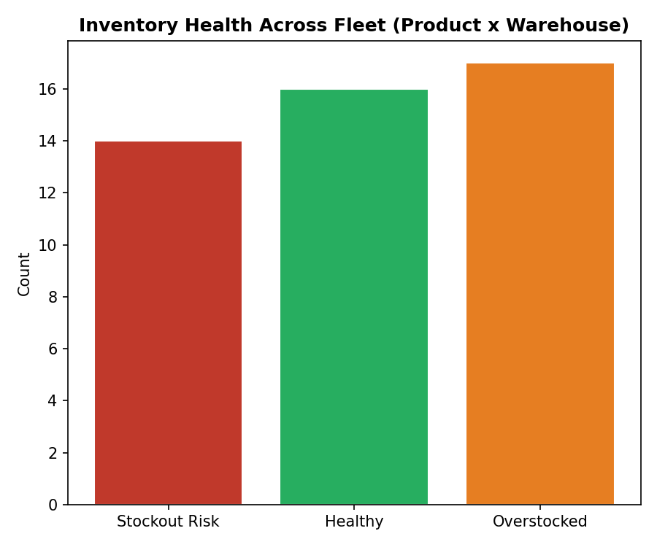
Top Overstocked Items by Capital Tied Up
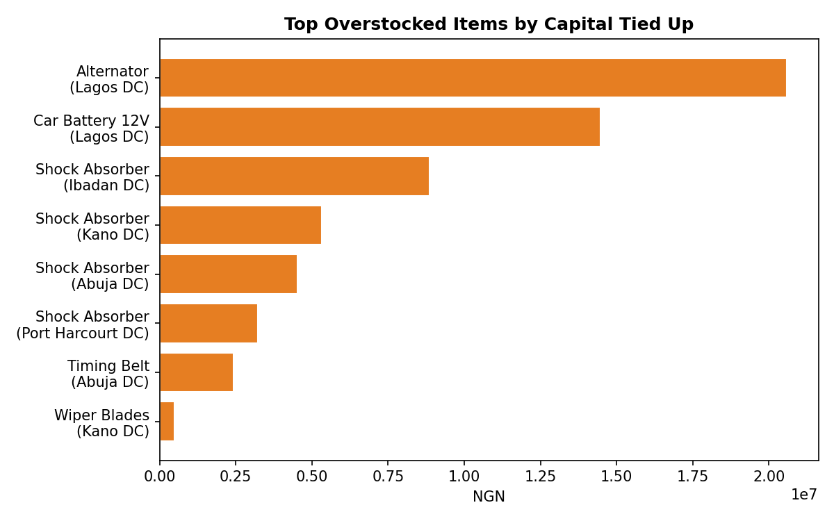
Recommendations
- Issue purchase orders immediately for the 14 stockout-risk items, prioritizing Radiator Coolant and Timing Belt given their 28-day lead times — these need ordering before the shortage happens, not after.
- Cut standing reorder quantities for Shock Absorbers fleet-wide — a single policy change here recovers a meaningful share of the NGN 61.4M in tied-up capital, more efficiently than fixing each warehouse individually.
- Introduce a lead-time-aware reorder point (days of supply < supplier lead time) as a standing rule in the ordering system, rather than relying on manual review — this is exactly the logic the SQL query in this project already automates.
- Fix the inventory data pipeline: 3 product/warehouse records were excluded from this analysis due to missing stock values from one source system's sync glitch — those need a manual stock count before they can be trusted in future reports.
Methodology Note (for technical review)
Data pipeline: two inventory source systems (different formats, one with missing values) combined via Power Query cleaning logic; combined model stored as a star schema in SQL Server (SupplyChainAnalytics database — see 01_schema.sql); reorder analysis via SQL queries joining sales velocity against supplier lead times (02_analysis_queries.sql); Power BI dashboard layer connects to the same SQL Server database for a live, filterable view by warehouse and category — see the Power BI build guide in the README.

